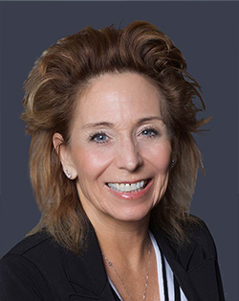
Sisters and Brothers,
I ask for a moment of your time to personally thank you for allowing me the honor and opportunity to serve you these past years as your National Business Agent. The commitment and determination I have put forth was simply to represent and serve you the members. My strength and the strength of this Region are exemplified through each and every member of Region 9. It has been my pleasure to provide educational training opportunities throughout Region 9 and at your State Conventions. I have also thoroughly enjoyed attending the local events in which you have allowed me to be a part of. These events have given me an opportunity to talk and meet with you in person.
We have suffered through a global pandemic and stood through economical strain as well as employability issues. Through it all we have remained unified. The facts are evident the fight must go on.
I have enjoyed working with your current branch leadership and feel confident you are receiving the best representation ever. Please continue to work with your stewards and officers, so you too can have a healthy career and reach your goal of retirement.
I will continue to proudly support the NALC goals and values even into my retirement. So it is with a humbling heart that I say thank you for all you do for this union and the American public you serve.
Yours in Unity,
Lynne Pendleton
National Business Agent
NALC Region 9

